

HOUSTON FIRE DEPARTMENT
NEEDED EQUIPMENT LIST
2026

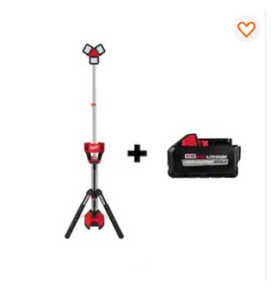

Milwaukee M18 18-Volt Lithium-Ion Cordless 6,000 Lumens Tower light with Charger and Battery
$500 each - 24 needed

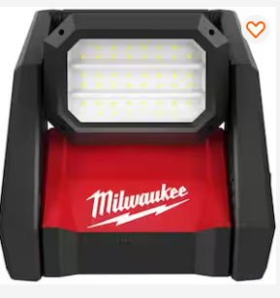
Milwaukee M18 GEN-2 18-Volt Lithium-Ion Flood Light
$149 each – 200 needed

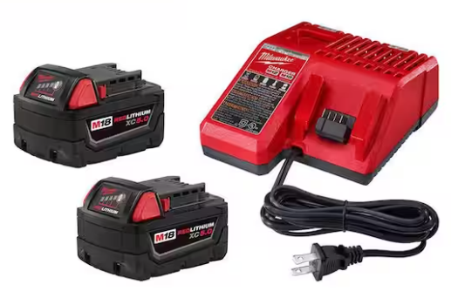
M18 18-Volt Lithium-Ion XC Starter Kit with Two Batteries and Charger Model #48-59-1852B
$179 each – 50 needed

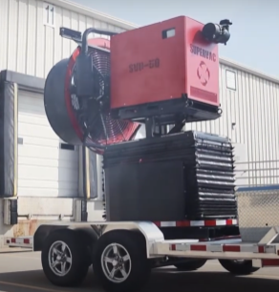
50” Positive Pressure Trailer-Mounted Fan
$225,000 – one needed

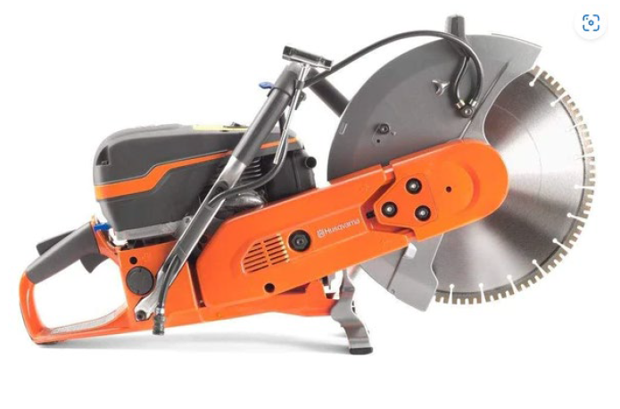
Husqvarna K970 Gas Power Saw
$1,902 each – 12 needed
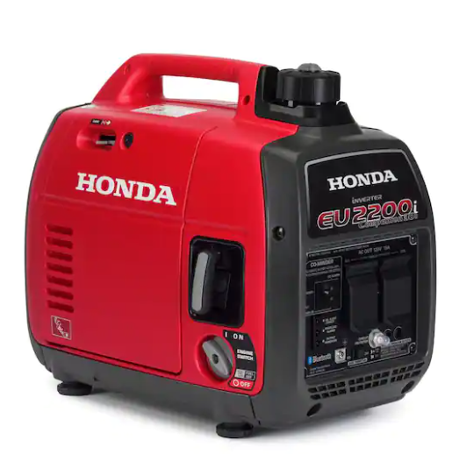

Honda 2200-watt Inverter Generator with 30 Amp Outlet Model #EU2200ITAN1
$1,299 each –
12 needed

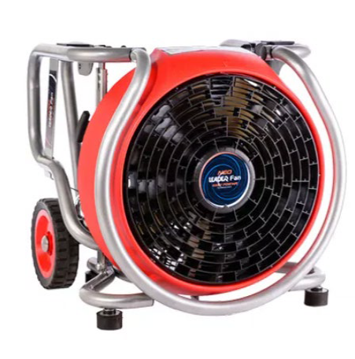

Leader MT240 Neo Gas Powered Blower Fan
$3,500 each – 12 needed

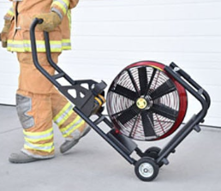
Leader EVG2300 Plug-In Electric Fan
$5,664 each – 10 needed

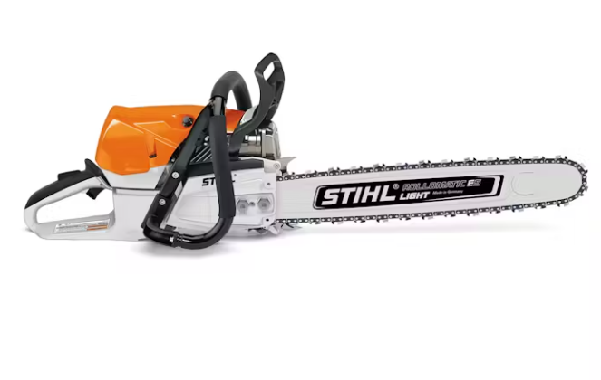
STIHL MS 462 CMR Ventilation Chainsaw
$1,700 each – 20 needed

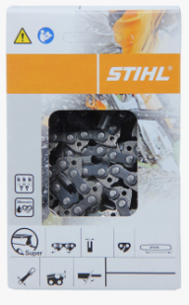
Carbine Chains for STIHL MS 462 Saw
$ 334 each – 24 needed
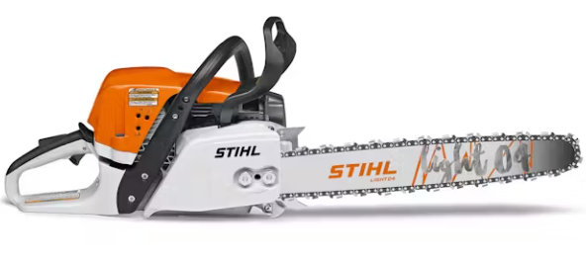
STIHL MS 391 Saw
$650 each – 20 needed

